**Retrieving the Product Details Using the Product ID**

**Screenshot**

**Index.html**

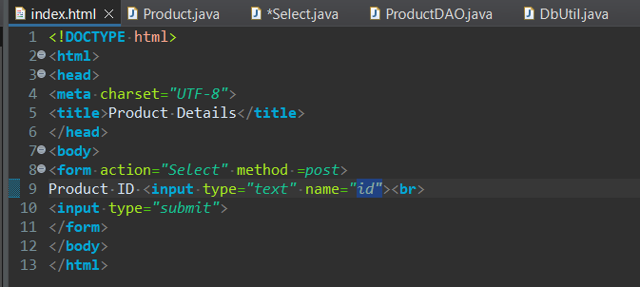

**Product.java**

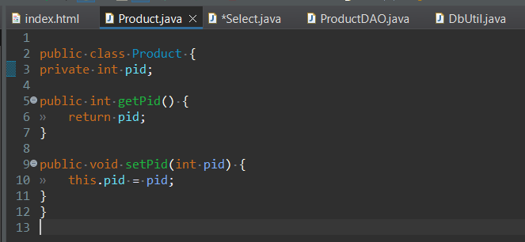

**Select.java**

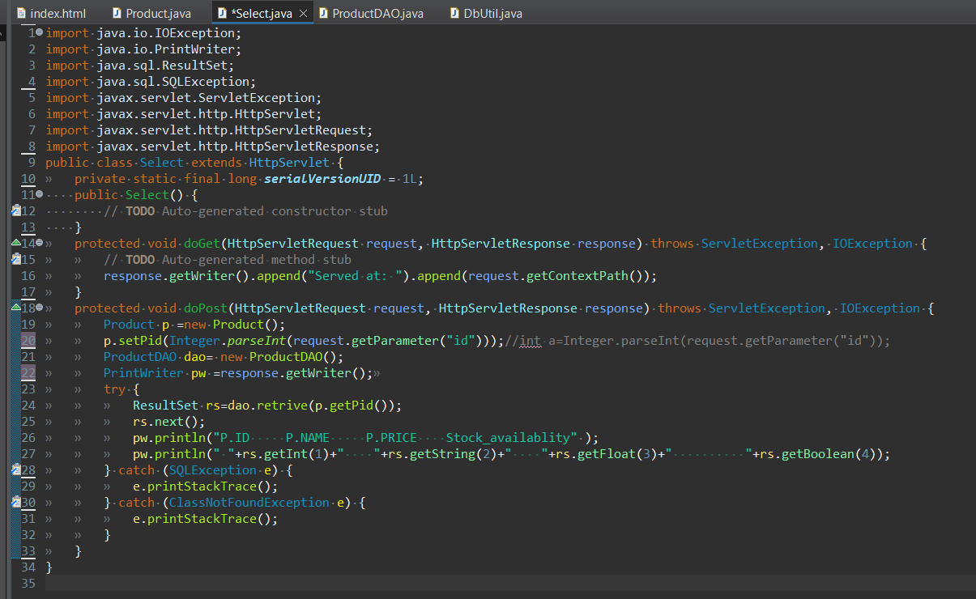

**DbUtil.java**

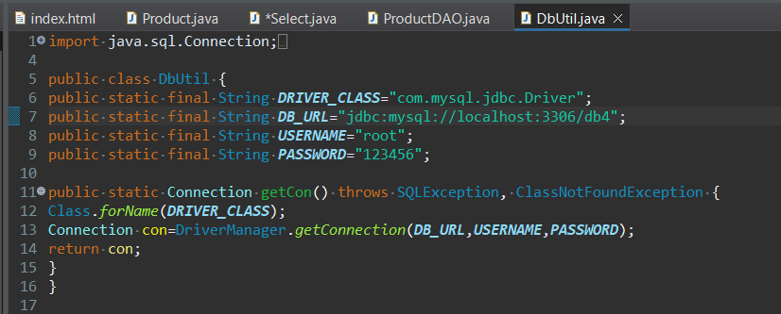

**ProductDAO.java**

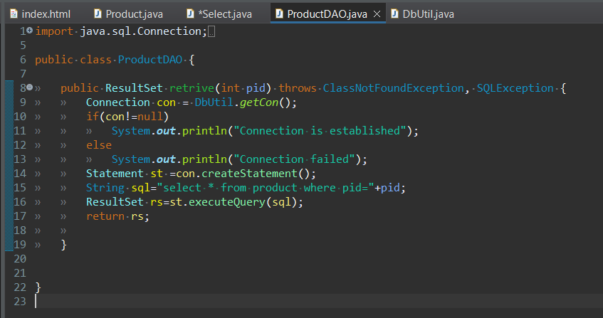

**SQL**

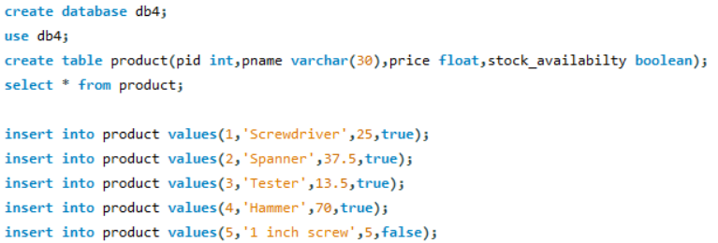

**OUTPUT**

